National Joint Registry data 2026

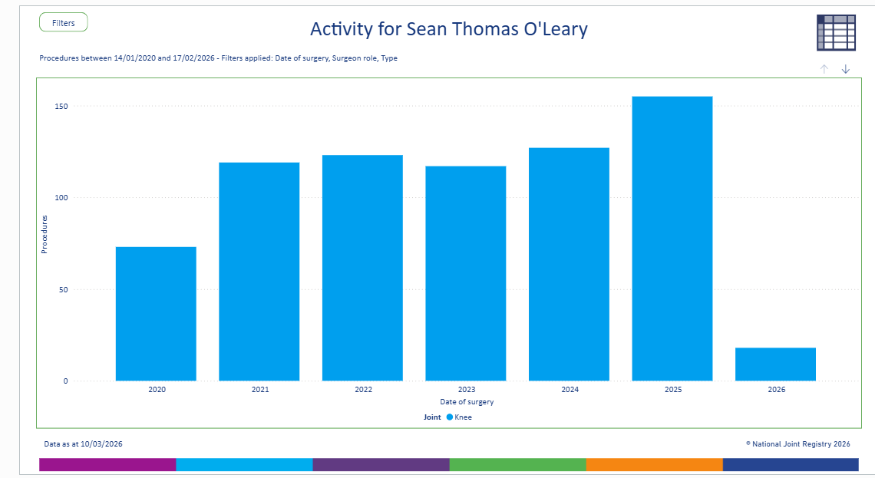
714 cases (UKR/TKR)
2020-2025

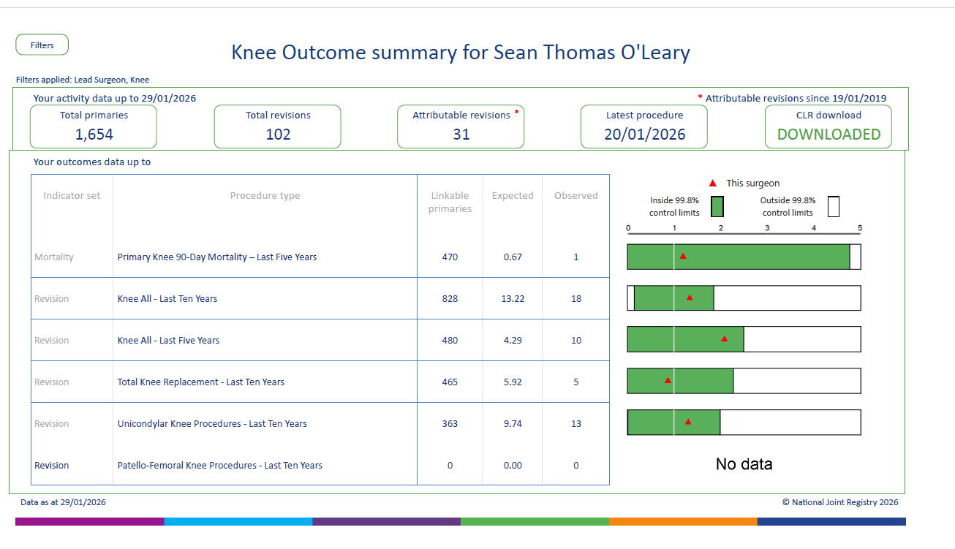

Mortality ratio
(number of deaths following joint replacement)
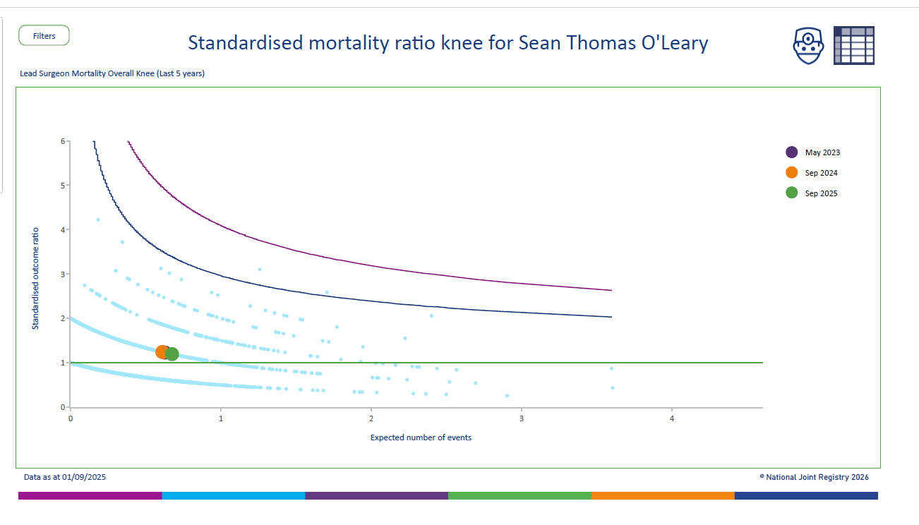

Revision rate (TKR last 5 years)
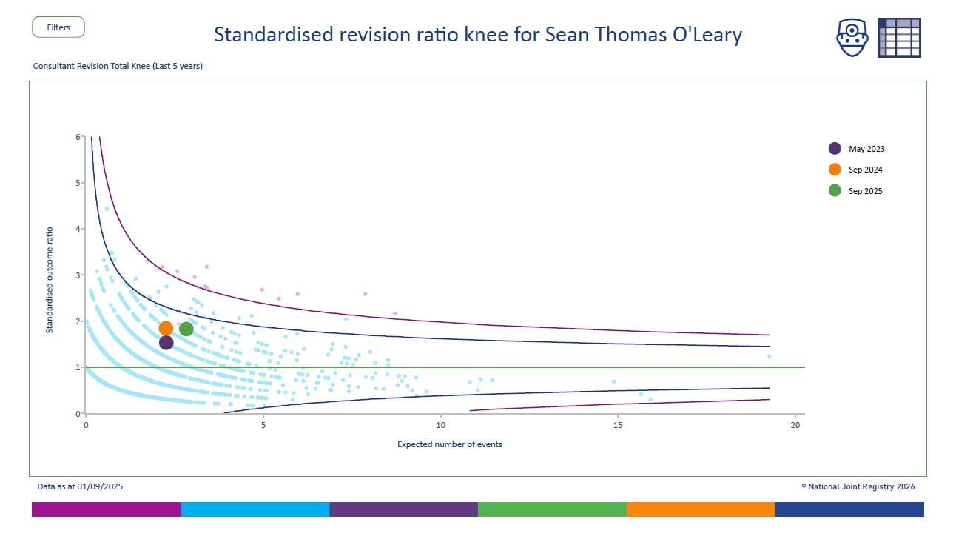

Revision rate (UKR last 5 years)

